Name: Junzhe Wu Net id: Junzhew3

1. Temporal noise versus output digital value

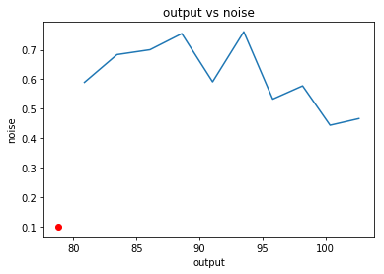

1. Output signal versus exposure time

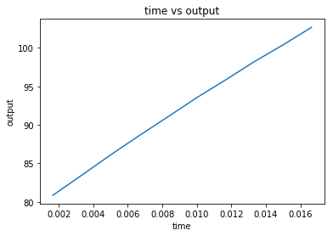

The non-linearity of the output is 0.01, we can find this curve is almost a straight line.

Factors contribute to the non-linearity:

1. Environment factors: The lighting condition of environment is not constant, it might have some slight change.
2. Internal factors: The nonlinearity of the pixel is mainly caused by the source follower’s variable gain and the nonlinear integration capacitor CFD.
3. SNR versus output signal

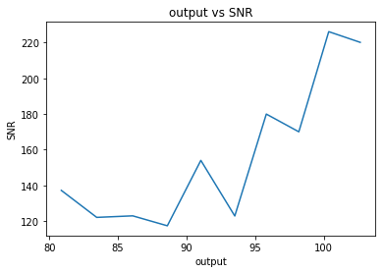

SNR is increasing as a function of the output signal.

Physical cause:

1. The output is increasing
2. The noise of the sensor will also increase although at lower rate than the output signal
3. FPN versus output signal

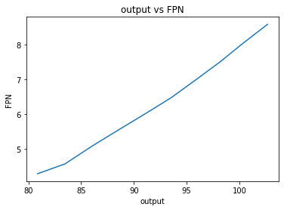

In the datasheet, it says that the FPN should less than 4 LSB in the 12 bit mode. But we use 8 bit mode and get FPN from 4-9.

1. The dynamic range = 103/0.0995 ≈ 1035. This result is really closed to the one reported in the datasheet.